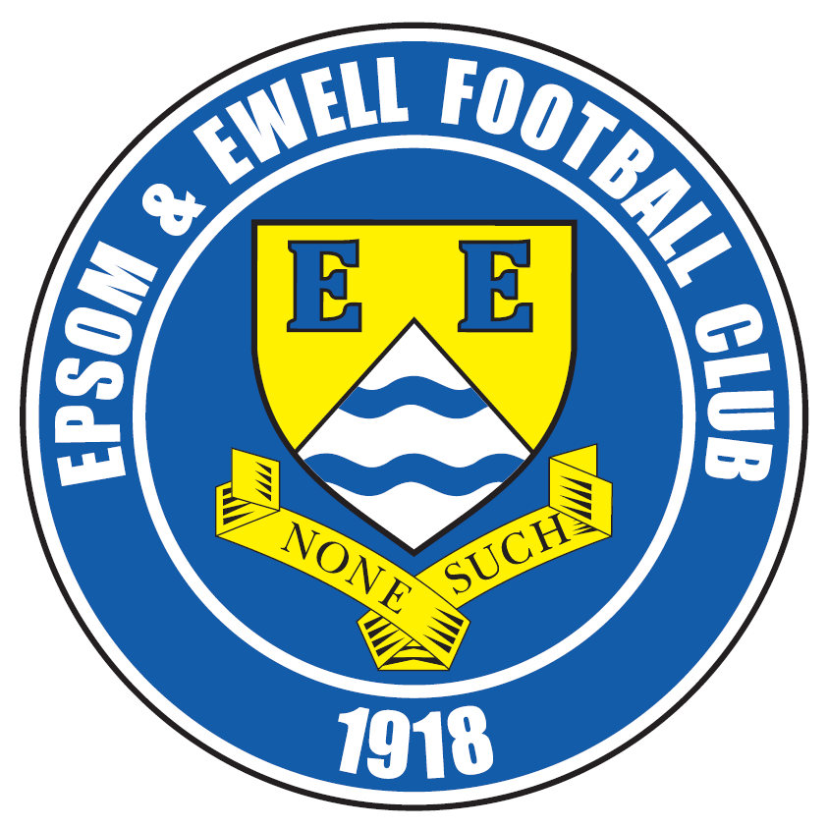 | Epsom & Ewell F.C.  18  v  Guildford City  Tuesday, 10th January 2017 – 7.45 p.m.
Good evening! We welcome the players, supporters and officials of Guildford City, today’s officials and of course, our own regular faces for this Surrey Senior Cup tie.

The fixture list is often full of surprises and due to our pairing in this competition, the match takes on a type of double header format as we are due to meet here in the League in just seven days!

I’ll be honest, when the draw came out, I expected us to be playing Horley Town as they were on a fine run at the time, but all credit goes to Guildford who recovered to win that tie on penalties following a 3-3 draw after trailing 2-0 at one point. For our part, we defeated our Step Four landlords Chipstead here 3-0 in one of our more complete performances of the season.

We have met once this season already, winning 2-0 at the Spectrum in November. It’s no exaggeration to say that the Surrey Senior Cup is probably fifth on our list of five playing priorities for the season after the financially beneficial F.A. Cup and F.A.Vase and the winnable League and League Cup, but our Management and Players will most definitely want to progress from this tie so it will be interesting to see what team we select this evening. Like us, Guildford remain in the League Cup where they host Raynes Park Vale; an arguably simpler task than our own trip to in form Walton & Hersham, but you never know, we may even meet once more later in the season.

On Saturday we hosted Spelthorne Sports and recovered a half time deficit to win 3-2. Our club wishes to apologise for the non-arrival of programmes on Saturday which were caused by matters outside of our control. A limited number have been reprinted and can be collected here today.

Our next match is on Saturday when we visit Hanworth Villa for the second time this season. We defeated them there 4-2 after extra time in the League Cup but were a little fortunate in the end to secure a 2-2 draw here in December. Still, we have an excellent record at the Ranch and have led after 85 minutes on each of our eight previous visits, winning six of them. Following that we welcome Guildford City back again next Tuesday.

We are also still looking for match and player sponsors, so if you would like to help us, please speak to any Committee Member and we can arrange this for you. The cost of a sponsorship is £55 while player sponsorship is £40.

All that remains to be said is that if the scores are level after 90 minutes we will go straight to penalties with no extra time being played.

Enjoy the game!

Rich

You can follow us on Facebook: www.facebook.com/epsomandewellfc
Twitter: @EEFCOfficial Instagram at: www.instagram.com/epsomandewellfc
and on Youtube at: www.youtube.com/channel/UCtLrpS0x5OaYUACRT34_zng

Cover photos by Gemma Jarman

- George Murphy scores our second goal against Guildford City in a 4-1 win on 30th Sept 2014

- Rob Hendry scores our opening goal at Guildford City in a 2-0 win on 5th Nov 2016


Cherry Red Records Combined Counties League
Premier Division Table 2016/17
incl Saturday 7th January | P | W | D | L | F | A | Pts | GD | H | A
Hartley Wintney | 28 | 23 | 3 | 2 | 91 | 27 | 72 | +64 | 18/3 | 1-3
Westfield | 26 | 16 | 6 | 4 | 58 | 29 | 54 | +29 | 18/2 | 1-2
Hanworth Villa | 29 | 16 | 5 | 8 | 50 | 33 | 53 | +17 | 2-2 | 14/1
Walton & Hersham | 25 | 13 | 9 | 3 | 43 | 24 | 48 | +19 | 4/3 | 1-1
Horley Town | 25 | 13 | 5 | 7 | 58 | 39 | 44 | +19 | 3-0 | 17/4
Camberley Town | 26 | 13 | 4 | 9 | 54 | 31 | 43 | +53 | 0-0 | 1/4
Epsom & Ewell | 25 | 12 | 7 | 6 | 58 | 37 | 43 | +21 | X | X
Knaphill | 26 | 13 | 3 | 10 | 53 | 49 | 42 | +4 | 4-0 | 8/4
Guildford City | 29 | 11 | 6 | 12 | 60 | 61 | 39 | -1 | 17/1 | 2-0
Bedfont Sports | 24 | 11 | 5 | 8 | 43 | 45 | 38 | -2 | 5-1 | 7/2
Abbey Rangers | 27 | 11 | 5 | 11 | 46 | 50 | 38 | -4 | 7-1 | 20/2
Windsor | 28 | 10 | 6 | 12 | 49 | 50 | 36 | -1 | 2-0 | 1-2
North Greenford United | 25 | 10 | 4 | 11 | 51 | 47 | 34 | +4 | 22/4 | 1-2
Colliers Wood United | 25 | 9 | 7 | 9 | 42 | 42 | 34 | 0 | 14/4 | 0-5
Spelthorne Sports | 26 | 9 | 5 | 12 | 44 | 48 | 32 | -4 | 3-2 | 25/2
AFC Hayes | 26 | 8 | 6 | 12 | 41 | 49 | 30 | -8 | 2-2 | 28/1
CB Hounslow United | 25 | 9 | 2 | 14 | 40 | 55 | 29 | -15 | 1-5 | 24/1
Farnham Town | 25 | 8 | 3 | 14 | 37 | 54 | 27 | -17 | 25/3 | 2-1
Sutton Common Rovers | 22 | 7 | 4 | 11 | 30 | 39 | 25 | -9 | 2-1 | 1-1
Chertsey Town | 26 | 6 | 6 | 14 | 34 | 63 | 24 | -29 | 2-1 | 11/2
Raynes Park Vale | 27 | 4 | 7 | 16 | 33 | 59 | 19 | -26 | 1-1 | 1-1
Badshot Lea | 26 | 5 | 3 | 18 | 32 | 69 | 18 | -37 | 4/2 | 4-1
Bedfont & Feltham | 27 | 4 | 5 | 18 | 32 | 79 | 17 | -47 | 21/1 | 9-2

Lucky Day? - 10th January
Played 11 - Won 6 Drawn 2 Lost 3 - For 18 Against 16 - PPG 1.82 - Good
Our Club record against today’s opponent
Played 17 - Won 10 Drawn 1 Lost 6 - For 34 Against 22 - PPG 1.82 - Good
Our Largest wins and losses against today’s opponent
2nd April 2016 - Won 5-1 - Combined Counties League (A)
14th September 2010 - Lost 1-5 - Combined Counties League (H)
Their Last Visit
5th December 2015 - Won 4-0 - Combined Counties League

Latest Results and Fixtures
Combined Counties League – Saturday 7th January
Abbey Rangers | 4-1 | Bedfont & Feltham
Bedfont Sports | 1-4 | Hartley Wintney
Camberley Town | 2-1 | Walton & Hersham
CB Hounslow United | 3-2 | Horley Town
Colliers Wood United | 0-2 | AFC Hayes
Epsom & Ewell | 3-2 | Spelthorne Sports
Farnham Town | 1-0 | North Greenford United
Hanworth Villa | 0-2 | Westfield
Knaphill | 2-0 | Badshot Lea
Raynes Park Vale | 2-2 | Guildford City
Surrey Senior Cup Third Round – Tuesday 10th January
Badshot Lea | V | Raynes Park Vale
Chertsey Town | V | Kingstonian
Epsom & Ewell | V | Guildford City
Merstham | V | Walton & Hersham
Combined Counties League – Tuesday 10th January
AFC Hayes | V | Bedfont Sports
Combined Counties League – Saturday 14th January
Abbey Rangers | V | Camberley Town
AFC Hayes | V | Westfield
Bedfont Sports | V | Chertsey Town
Farnham Town | V | Raynes Park Vale
Guildford City | V | Knaphill
Hanworth Villa | V | Epsom & Ewell
Horley Town | V | Sutton Common Rovers
North Greenford United | V | Colliers Wood United
Spelthorne Sports | V | Hartley Wintney
Walton & Hersham | V | CB Hounslow United
Windsor | V | Badshot Lea
Combined Counties League – Monday 16th January
Sutton Common Rovers | V | Windsor
Combined Counties League Cup QF – Tuesday 17th January
Westfield | V | Camberley Town
Combined Counties League – Tuesday 17th January
Badshot Lea | V | Chertsey Town
Epsom & Ewell | V | Guildford City
Farnham Town | V | Walton & Hersham
Horley Town | V | Bedfont & Feltham
Knaphill | V | Bedfont Sports
Raynes Park Vale | V | CB Hounslow United

From behind the goal
Epsom & Ewell 3-2 Spelthorne Sports
Combined Counties League - Premier Division - Saturday 7th January 2017

Ferdinando strike makes the difference for the third time in a row
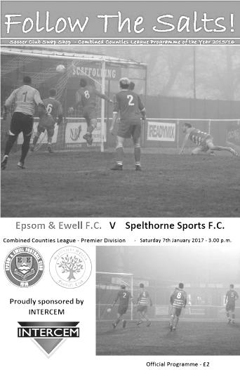
Back in 2014 Spelthorne Sports came away from their first visit to High Road with a win on penalties in a Southern Combination Cup tie. Since then we have met on five occasions in the league with our boys coming out on top on every occasion. Although two of those wins were heavy ones in Middlesex, the three home wins in the league have all been by a single goal and on each occasion the winning goal has been scored by Matt Ferdinando.

Following Monday's draw at Sutton Common Rovers we made two changes. Captain Dan Dean was working and Charlie Clark-Gleave came in for him, while Ferdinando came in for Daryl Cooper-Smith. With Reisse Griffin remaining on the right wing, this meant that Ferdinando played behind Hendry in a more central role.

As the match started we had a couple of unusual situations. Firstly we had the sight of Michael Eacott becoming the first keeper in club history to wear black. This was all the more surprising as the referee was also wearing the same colours! Then a few minutes in Hendry was flagged offside by one of the Assistants, even though it was from an Eacott goal kick! We didn't start that well either with the opening five minutes spent in our own half as the visitors passed the ball around confidently. Fortunately they didn't take advantage of the possession and we began to get into the match.

We earned a number of corners in the first half and many of these caused trouble. One from Ferdinando was palmed away by the Spelthorne keeper Kavanagh Keadell but the ball fell to a defender and was cleared. Ferdinando's next corner almost went in directly at the far post but Keadell was there just in time to knock the ball away. From that corner Jordan Gallagher hit the ball powerfully enough from over 25 yards but the ball deflected off a defender and flew away for a further set piece.

In the 18th minute we had a good chance when a deep free kick from Agi Panayiotou was headed across goal by James Taylor but although Matt Farrell was on it first, our Captain was unable to keep his volley down from just eight yards out. Spelthorne then took the lead in the 27th minute with a free kick that was headed over Eacott by Jack Ball. This was a poor goal to concede and before the delivery I could hear Eacott calling that we were too deep for the kick. Clearly we didn't have time to reorganise and Ball was able to stroll unmarked inside the area and flicked his header over the exposed Eacott.

We responded well and a good run by Gallagher ended with a ball in to Hendry at the near post but his shot was blocked by a defender. This was followed by a good cross in by Matt Tanton, but Farrell was unable to direct his header on target from 12 yards. Farrell was unfortunate again after Griffin and Adam Heagney combined with the latter delivering a near post ball in but our man's flick was just over the bar. Griffin was next to strike at goal but was just wide with his shot on the turn after good work from Hendry and Ferdinando. As the half came to an end Craig Hastings entered the fray for the injured Clark-Gleave before we had our best opportunity in injury time when Panayiotou showed great skill to control the ball and beat two men on the edge of the area only to blaze his shot over from just inside the box.

It was beginning to look like one of those days but we were creating chances and continued to keep the tempo up, earning a penalty for a clumsy challenge on Ferdinando by Joe Dyett. Farrell stepped up to send Keadell the wrong way from the spot in the 51st minute and we were back in the game. Farrell was unfortunate not to get another opportunity moments later when a great Gallagher cross looked as though it would fall for him but was just knocked away from him by a defensive glancing header. However, in the 61st minute Gallagher's delivery had the desired result when Hendry met his cross with a superb volley. Despite the strike being only six yards out, Keadell made a superb save to parry the ball away but Hendry was able to react to reach it first before dummying the incoming defender and stroking the ball into the bottom corner from close range to give us the lead.

Griffin headed a near post Ferdinando corner just wide as we continued to press and he saw another effort deflected wide from a near post Ferdinando free kick on the right wing this time, only to see a goal kick awarded for his trouble. It didn't matter though as in the 73rd minute we had the bit of magic we had been waiting for as the ball fell kindly for Ferdinando and he lashed it into the net from just over 25 yards. From standing behind the goal I can confirm that it didn't waver at all and was dead straight, with the power of the strike giving Keadell no chance.

It looked like we would have a comfortable home win for the first time in a while but within two minutes the visitors had reduced the deficit with a towering Ball header from a good right wing delivery. This didn't really change the balance of play though and we finished the stronger of the two teams and could have had a penalty towards the end when Gallagher appeared to be caught in the area. However, he had fallen over quite theatrically on a couple of earlier occasions and the referee was understandably not going to give our left winger the benefit of any doubt as a result!

This win was a big one for our players after dropping points in recent matches and it must be said that we showed great character to turn this match around in the second half. Additionally, many of the other sides around us lost so we have recovered much but not all of the damage caused by our recent draws. Next up is a break from league action as we entertain Guildford City in the Surrey Senior Cup on Tuesday.

Epsom and Ewell: Michael Eacott, Adam Heagney, Matt Tanton, James Taylor,
Charlie Clark-Gleave, Savvas 'Agi' Panayiotou, Jordan Gallagher, Matt Farrell (c),
Rob Hendry, Matt Ferdinando, Reisse Griffin
Subs: Craig Hastings for Clark-Gleave (44), Daryl Cooper-Smith for Hendry (67),
Jason Nwachukwu for Ferdinando (83)

Guildford City – History
The first club in the town was amateur side Guildford FC, formed in 1877, and known as the “Pinks”. They played home matches at the Woodbridge Road Sports Ground. A successful start led to a number of people mooting a new professional club and by the end of 1920 a professional side was formed, being they were accepted into the Southern League May 1921, the equivalent of today’s Conference League.

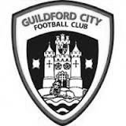
1927 saw the coming of Guildford as a Diocese and with it the building of a Cathedral. It was believed that Guildford would become a city so the Club changed its name and the “City” was born. At this time they also changed the colours to red and white stripes.

1927 saw Guildford become a Diocese and, coupled with the planned cathedral, it was believed that Guildford would become a city so the Club was renamed Guildford City. Although they had little early success in the League, the FA Cup bought a taste of glory in 1928-29 when, having battled through the qualifying rounds, they beat Queens Park Rangers 4-2 in the First Round Proper in front of a crowd of nearly 8,000. In the next round they were at home to Bournemouth but a similar crowd saw the visitors romp home 5-1.

In 1928-29 City were drawn at home to Queen’s Park Rangers in the FA Cup First Round proper and won 4-2 in front of almost 8,000 spectators. Despite excellent gates and the highest League finish to date the Club was facing a financial crisis at the end of the season – this was to be a recurrent theme throughout the Club’s history. At the start of the 1936/37 season the Club made the massive decision to turn full-time professional, appointing Haydn Green as manager. That season they finished fourth but next season things got even better.

1937/38 saw victory over Reading in the FA Cup but in the League they won 22 of their 34 games to finish as Southern League Champions for the first time. That feat was nearly repeated the following year, with City finishing runners-up to Colchester United by 1 point, scoring 126 goals in the process. Indeed the League game at home to Colchester on Easter Monday saw City win 3-1 in front of the highest crowd ever for a League game at Joseph’s Road 9,443. Earlier that season City had attracted an even bigger crowd to Joseph’s Road for an FA Cup 1st Round Replay against local rivals Aldershot. 9,932 saw City lose a nail-biting game 4-3.

This successful period was brought to a premature conclusion by the outbreak of the Second World War. The ground had been used by the Army during the War and it wasn’t until 1946/47 that City re-entered the Southern League – this time as a part-time club. They finished runners-up, this time to Gillingham but there followed 3 seasons of mediocrity. In 1950/51 the team finished 3rd in the League and reached the final of the Southern League Cup for the first time, losing to Merthyr Tydfil despite winning the first leg.

The 1951/52 season saw the longest trip ever undertaken by the City when they were drawn away to Gateshead in the 2nd Round of the FA Cup. An estimated 5,000 supporters made the overnight trip to the North East of England in December (there were no motorways in those days, and no heaters on coaches either!). A 15,000 crowd saw City dominate the game but lose 2-0. In debt again, City sold Jimmy Langley to Leeds for £2,000 – who eventually joined Fulham and earned three England international caps.

Archie Macaulay was brought in as player-manager in 1953 and he started building a side that would win the title in 1955/56. However, he left before the end of the season leaving Bill Thompson to take over and lead the side to the championship. In 1958/59 the League expanded and was regionalised. City were in the South Eastern zone and could only finish 15th out of 17.

For 1959 the League was revised again, this time to a Premier and First Division. City’s miserable time the year before meant they started in the lower division. Albert Tennant, who had been a coach at Chelsea,

took charge and he led City to promotion. After a season of consolidation, the next four seasons saw finishes of 3rd, 4th, 4th and 2nd: on the last occasion only 2 points behind champions Weymouth. In the

1962/63 season they also lifted the Southern League Cup for the first time, beating Nuneaton Borough 2-1 on aggregate over two legs.

Despite this success by the summer of 1965 it seemed that finance was again a major problem at the Club. A strict budget left the club short of players, resulting in a disappointing 16th place finish, although they did manage to reach the final of the Southern League Cup again. They went on better the next year, winning the Southern League Cup with a 2-1 aggregate success over Barnet.

1967/68 saw a notable FA Cup run. Drawn away to Brentford the City were leading 2-1 when the match was abandoned during the second half because of snow. A second trip to Griffin Park ended with a 2-2 draw and meant a replay at Joseph’s Road in front of 7,500 fans who roared City to a famous 2-1 victory. Goalkeeper Peter Vasper was sold to Norwich City for £5000 and it was thought that this money and the money from the Cup games might ease the Club’s financial problems but they were worse than many had realised. The following season saw the end of Albert Tennant’s nine year reign and the Club was relegated.

In 1969/70 Joseph’s Road was sold to signal the beginning of the end for the Club. The following year they reached the second round of the FA Cup but the inevitable was only being delayed and although in 1972/73 the Club again reached the first round of the FA Cup (a visit to Watford ended with a 4-2 defeat), they could only finish 18th in the League. Crowds of 4,000 were needed to break even but barely a quarter of that was achieved at most games.

The Surrey Advertiser advised a new board of directors in place for 1973/74 with Bill Bellerby elected President (recently elected as Patron of the new club) and Club stalwart Darby Watts as player manager. Despite the best efforts of Mr Bellerby and the long standing Chairman of the Supporters’ Club John Daborn, it was soon announced that the Club was to merge with Dorking and play at Meadowbank. The final game at Joseph’s Road was played on 12th February 1974 when the City beat Folkestone 2-0 in front of 625 fans. After 53 years senior football at Joseph’s Road had come to an end.

In 1996 Bill Bellerby, then Mayor of Guildford, enquired as to whether Burpham FC would be prepared to move to the Spectrum Leisure Centre and represent Guildford. Spectrum provided a venue which had the potential for development into senior football and already had floodlighting. AFC Guildford played in the Surrey Premier League, which eventually became Division One of the Combined Counties League. In 2003/04 AFC Guildford were crowned champions of Division One and gained their first ever major honour.

Promotion was obtained into the Combined Counties Premier Division, ground-sharing with Cranleigh FC while Spectrum was upgraded to an acceptable standard. In early November 2004, AFC Guildford returned to their home ground near to the town centre.

After a 12 month period as Guildford United, the club was re-named the historically significant ‘Guildford City’, after an absence of thirty years. 2007-2008 saw City claim a runner up finish in the Combined Counties Premier League, under the management of Scott Steele and Lloyd Wye. Then saw a period of struggle which was only alleviated by the inspirational appointment of Kevin Rayner, and his assistant Roly Martin, who took charge in spring 2009.

Their first full season at City saw a much improved seventh place finish in 2009-10. The following year saw a good run in the FA Vase, an incredible FA Cup victory at Ryman Premier Tonbridge Angels, but also the Combined Counties Premier Division Championship. A second Combined Counties Championship was gained in 2012, resulting in an emotional return to the Southern League after a gap of 38 years.

Change was on the way after a creditable ninth place finish in the Central division. At the conclusion of 2012-13 Rayner departed for a new chapter in his career. However in November 2013 he returned to the Spectrum to lead an ultimately unsuccessful battle against relegation from the Southern League.

After a poor start to the 2014-15 Combined Counties League season, Kevin Rayner departed in November to be replaced by local coach Donovan Chislett who ultimately saved the club from relegation in an exciting climax to the season. Donovan himself departed in September 2015 to be replaced by former Godalming Town manager Dean Thomas but he was replaced by Steve Dormer.

Guildford City – Player Profiles
Steve Dormer (Manager): Dormer has considerable experience as both a player and coach at AFC Wimbledon, Southall, Yeading, Wealdstone, Spelthorne Sports and Camberley Town. He stepped up from assistant to the manager’s position in following Dean Thomas’s departure.

Chris Balchin (Assistant Manager): A former Merrow FC manager who is Guildford through and through, having previously been involved in the club’s junior section.

Dan Akinwande: A powerfully built striker or midfield player who graduated through the Fulham youth system, and has now signed for the club for a second spell. His former clubs include Cove, Dorking, Frimley Green and Banstead Athletic.

Luke Badiali: A goalkeeper who joins City after a brief spell at Westfield. His former clubs include Walton Casuals, Walton & Hersham, Tooting & Mitcham, Sutton United and Fulham U’21s.

Tom Bingham: A 20 year old striker who initially came through the junior system at Maidstone United. He subsequently has played and scored goals at Youth, U21 and senior level for Crawley Down Gatwick, Horsham and Three Bridges. He is currently out of action with a back injury.

Tom Booth: A powerful right sided player who is comfortable playing at full back or in midfield where he has impressed this season. His former club is Godalming and Farncombe Athletic.

Alpha Cauwenbergh: A strong and powerful striker who has played much of his football this season in the AFA with Civil Service FC. His former clubs include Frimley Green, Cobham, Corinthian Casuals and Walton Casuals.

Suleiman Djalo: An attacking full-back or wide player with Southern League experience at North Greenford United. He spent a brief spell at Colliers Wood United earlier this season.

Mario Embalo: A former Benfica junior who during a seven year spell at Colliers Wood scored over 100 goals, becoming in the process one of the CCL’s most prolific strikers. In the 2014-15 season he netted on 49 occasions, and with his pace and work rate he is a fine addition to the Guildford squad.

Lee Hall: A hard working midfield player who adds vital experience to an otherwise young squad. He joined City from Tooting & Mitcham. His other clubs include Harrow Borough.

Greg Haydon: A composed defender who has impressed since joining City this season. His previous clubs include AFC Wimbledon, East Grinstead and Dorking Wanderers.

Jamel Johnson: A former AFC Wimbledon and Aldershot Town Academy midfielder with great energy. At his best he goes through gaps that aren’t there.

Cameron Karembo: A full-back who developed through the Carshalton Athletic junior system, before joining the Aldershot Town Academy. He subsequently has played for Fleet Town, Tooting & Mitcham and briefly Godalming Town.

Leon Lalor-Dell: An exciting wide player with first team experience at Tooting & Mitcham where he developed through their youth system.

Shawn Lyle: A young forward who joins City after two spells each at both Walton and Hersham and Whyteleafe. Popular in the dressing room.

Kiye Martin: A skilful wide player who was a full-time professional at Crystal Palace before released at the end of the 2014-15 season. He joins City from Leatherhead.

Adriano Moraes: A Brazilian born central defender who joined City in December 2016 after being released by Tooting & Mitcham.

Robert Mundow: A Leatherhead U21 midfield player signed on dual registration to gain first team experience.

Matt Petts: An accomplished goalkeeper who appeared for Farnham Town last season culminating in a CCL League Cup final appearance. He has also appeared this season for Petersfield Town in the Southern League.

Alex Rose: A left sided defender who likes to get forward to support the attack. His former clubs include Redhill and Dorking Wanderers.

Darryl Siaw: The club Captain who is a highly mobile defender who originally came through the Staines Town academy. He first played senior football for Walton Casuals before signing in January 2014 for Farnborough FC, for whom he made 50 appearances in Conference South. After briefly signing for Tooting & Mitcham in July 2015, he subsequently re-joined Farnborough in the autumn and it is from there he joins City.

Callum Wilson: A highly promising 19 year old full-back with Tooting & Mitcham who has signed on dual registration forms. He formerly played at Merstham FC.

First Eleven Appearances 2016/17 - (max 33)
Name | Debut | 2016/17 |  |  |  | Career Totals
Name | Debut | App | Sub | Total | Goals | App | Sub | Total | Goals
CLARK-GLEAVE Charlie | 23/08/2016 | 3 | 2 | 5 | 0 | 3 | 2 | 5 | 0
COOPER-SMITH Daryl | 03/01/2015 | 24 | 2 | 26 | 25 | 54 | 10 | 64 | 45
DEAN Dan | 02/08/2014 | 23 | 2 | 25 | 0 | 91 | 6 | 97 | 2
DEWAR Ali | 29/10/2011 | 0 | 1 | 1 | 0 | 55 | 36 | 91 | 10
EACOTT Michael | 02/08/2014 | 26 | 0 | 26 | 0 | 111 | 1 | 112 | 0
FARRELL Matt | 02/08/2014 | 31 | 0 | 31 | 14 | 117 | 4 | 121 | 32
FERDINANDO Matt | 20/09/2014 | 16 | 6 | 22 | 3 | 69 | 12 | 81 | 17
GALLAGHER Jordan | 07/08/2016 | 19 | 12 | 31 | 9 | 19 | 12 | 31 | 9
GRIFFIN Reisse | 08/08/2015 | 24 | 5 | 29 | 2 | 52 | 11 | 63 | 4
HASTINGS Craig | 08/08/2015 | 21 | 6 | 27 | 1 | 58 | 10 | 68 | 1
HEAGNEY Adam | 16/08/2016 | 21 | 4 | 25 | 0 | 21 | 4 | 25 | 0
HENDRY Rob | 08/08/2015 | 23 | 7 | 30 | 6 | 53 | 18 | 71 | 18
MCKAY Alex | 20/12/2008 | 16 | 3 | 19 | 3 | 124 | 33 | 157 | 11
NEALE Tom* | 13/10/2015 | 6 | 5 | 11 | 7 | 22 | 24 | 46 | 17
NORTH Rhys* | 16/08/2015 | 2 | 2 | 4 | 0 | 19 | 9 | 28 | 1
NWACHUKWU Jason | 01/10/2016 | 5 | 9 | 14 | 0 | 5 | 9 | 14 | 0
PANAYIOTOU Savvas | 03/01/2015 | 26 | 3 | 29 | 4 | 58 | 11 | 69 | 11
PRICE Matt* | 23/08/2016 | 2 | 0 | 2 | 1 | 2 | 0 | 2 | 1
ROBINSON Sam* | 22/10/2011 | 7 | 1 | 8 | 1 | 61 | 6 | 67 | 14
ROSE Daniel | 25/10/2016 | 2 | 5 | 7 | 0 | 2 | 5 | 7 | 0
SALEH Mennar* | 24/09/2016 | 0 | 2 | 2 | 0 | 0 | 2 | 2 | 0
SMITH Matt | 08/08/2009 | 0 | 2 | 2 | 1 | 91 | 45 | 136 | 11
TANTON Matt | 02/08/2014 | 28 | 1 | 29 | 1 | 85 | 5 | 90 | 3
TAYLOR James | 26/08/2013 | 27 | 3 | 30 | 2 | 113 | 15 | 128 | 8
THOMPSON Elliott | 09/02/2016 | 3 | 0 | 3 | 1 | 7 | 9 | 16 | 1
TURPIE Alistair | 31/03/2016 | 7 | 1 | 8 | 0 | 9 | 1 | 10 | 0
WATRET Jack* | 02/08/2016 | 1 | 0 | 1 | 0 | 1 | 0 | 1 | 0
* player has left the club

Combined Counties League Premier Division Opponents
All-time Records
incl Saturday 7th  January | P | W | D | L | F | A | PPG | GD | Best  Win | Worst  Loss
Bedfont & Feltham | 1 | 1 | 0 | 0 | 9 | 2 | 3.00 | +7 | 9-2 | X
Spelthorne Sports* | 6 | 5 | 1 | 0 | 15 | 6 | 2.67 | +10 | 6-2 | X
Sutton Common Rovers | 12 | 9 | 2 | 1 | 30 | 14 | 2.42 | +16 | 4-0 | 1-4
Horley Town | 29 | 20 | 5 | 4 | 65 | 30 | 2.24 | +35 | 6-0 | 1-3
Colliers Wood United | 22 | 14 | 2 | 6 | 45 | 33 | 2.00 | +12 | 4-0 | 0-5
Bedfont Sports | 10 | 6 | 2 | 2 | 18 | 11 | 2.00 | +7 | 5-1 | 0-4
Abbey Rangers | 3 | 2 | 0 | 1 | 10 | 4 | 2.00 | +6 | 7-1 | 2-3
Westfield | 19 | 11 | 3 | 5 | 40 | 31 | 1.89 | +9 | 6-1 | 0-4
Farnham Town | 14 | 8 | 2 | 4 | 25 | 23 | 1.86 | +2 | 3-1 | 1-4
Knaphill | 7 | 4 | 1 | 2 | 15 | 8 | 1.86 | +7 | 4-0 | 1-2
Guildford City | 17 | 10 | 1 | 6 | 34 | 22 | 1.82 | +12 | 5-1 | 1-5
Hanworth Villa | 16 | 8 | 4 | 4 | 38 | 26 | 1.75 | +12 | 5-0 | 1-4
Badshot Lea | 18 | 8 | 3 | 7 | 35 | 34 | 1.67 | +1 | 4-1 | 0-4
Walton & Hersham | 50 | 24 | 10 | 16 | 101 | 97 | 1.64 | +4 | 6-0 | 0-8
Raynes Park Vale | 28 | 13 | 7 | 8 | 59 | 38 | 1.64 | +21 | 6-1 | 0-2
Camberley Town* | 89 | 38 | 22 | 28 | 158 | 123 | 1.52 | +35 | 9-1 | 0-4
Hartley Wintney | 11 | 4 | 3 | 4 | 26 | 20 | 1.36 | +6 | 5-0 | 2-4
Windsor | 49 | 19 | 12 | 18 | 90 | 90 | 1.41 | 0 | 4-0 | 0-6
Chertsey Town | 48 | 18 | 5 | 25 | 72 | 87 | 1.23 | -15 | 3-0 | 0-7
AFC Hayes | 9 | 2 | 3 | 4 | 18 | 17 | 1.00 | +1 | 7-0 | 0-3
North Greenford United | 11 | 3 | 2 | 6 | 15 | 20 | 1.00 | -5 | 3-0 | 1-4
CB Hounslow United | 2 | 0 | 0 | 2 | 2 | 7 | 0.00 | -5 | X | 1-5
* includes one abandoned match v Camberley and one loss on penalties v Spelthorne

Player Sponsorship
Here is the current list for the 2016/17 season showing all of our players and Management that are available for sponsorship.

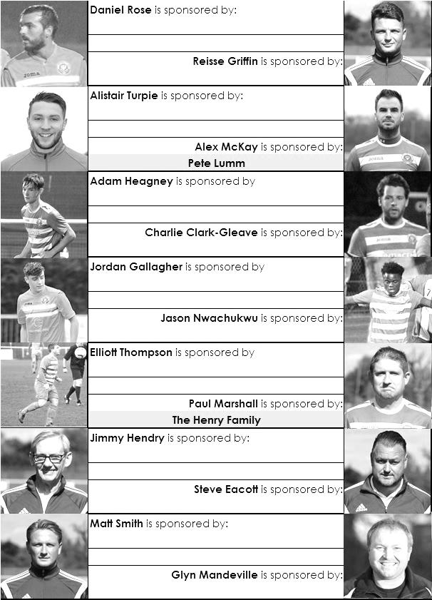

Sponsorship costs just £40 and it is easy to do. Just select a player who has not been previously sponsored and let a Committee Member know that you would like to sponsor them. Beware though. Until we have received the money it is possible for someone to jump in front of you, so don’t delay, sponsor today!
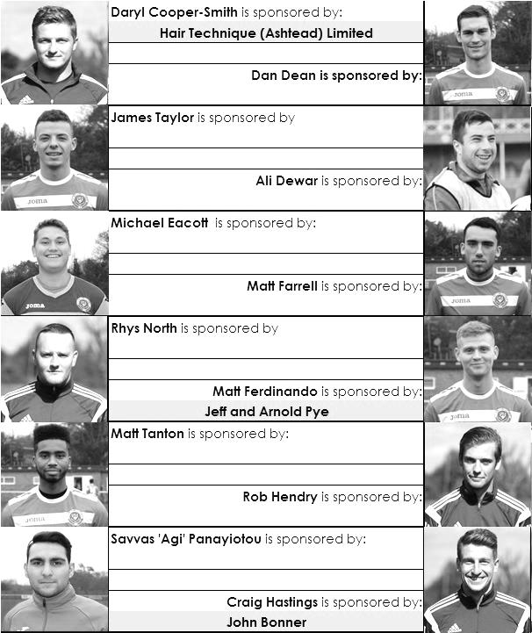

Centre page for results

Centre page for results


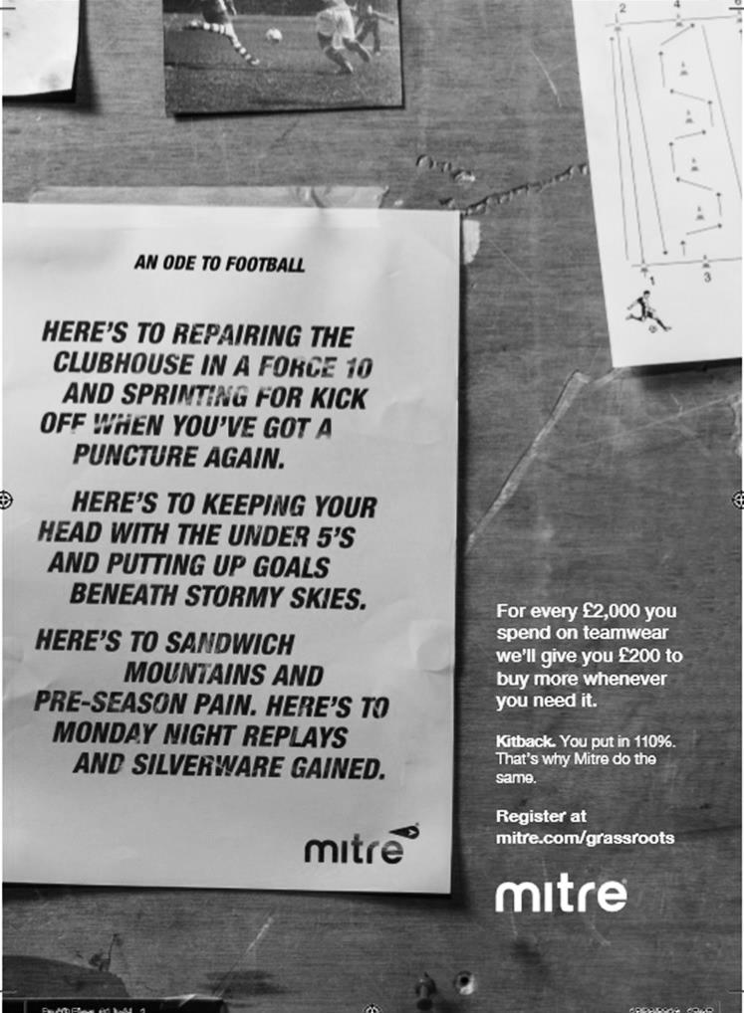

Surrey Senior Cup
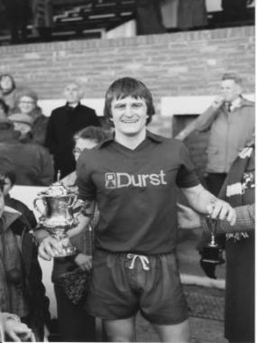
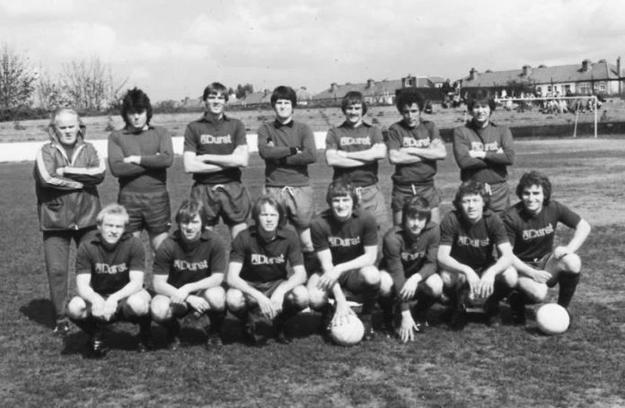
Second Round
Met Police | 0-0 | Kingstonian
Match played at Met Police F.C. – Kingstonian won 7-6 on penalties
Ashford Town (Mx) | 0-1 | Knaphill
Woking | 4-0 | Walton Casuals
Whyteleafe | 5-1 | Colliers Wood United
Guildford City | 3-3 | Horley Town
Guildford City won 3-2 on penalties
Egham Town | 3-0 | Corinthian Casuals
Godalming Town | 0-1 | Merstham
Molesey | 0-1 | Leatherhead
Raynes Park Vale | 1-1 | Sutton United
Raynes Park Vale won 4-3 on penalties
Sutton Common Rovers | 5-1 | Camberley Town
Dorking Wanderers | 2-1 | South Park
Badshot Lea | 1-0 | Farnham Town
Walton & Hersham | 3-0 | Croydon
Carshalton Athletic | 0-2 | Tooting & Mitcham United
Chertsey Town | 2-1 | Abbey Rangers
Epsom & Ewell | 3-0 | Chipstead
Third Round
Whyteleafe | 24/1 | Egham Town
Badshot Lea | 10/1 | Raynes Park Vale
Epsom & Ewell | 10/1 | Guildford City
Dorking Wanderers | 24/1 | Sutton Common Rovers
Kingstonian | 10/1 | Chertsey Town
Woking | 10/1 | Leatherhead
Merstham | 10/1 | Walton & Hersham
Tooting & Mitcham United | 24/1 | Knaphill

EL Records Premier Challenge Cup
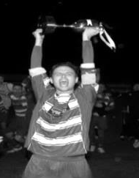
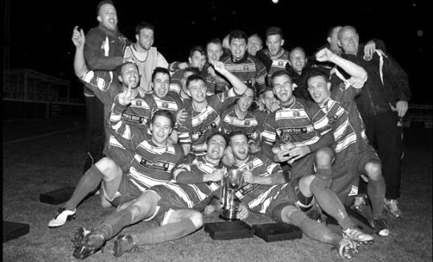
Second Round
Hanworth Villa | 2-4+ | Epsom and Ewell
AFC Hayes | 3-4 | Balham
Epsom Athletic | 1-5 | Windsor
Sutton Common Rovers | 2-1 | Bedfont Sports
Raynes Park Vale | 2-0 | Colliers Wood United
Frimley Green | 1-2 | Banstead Athletic
Westfield | 8-4+ | Redhill
Staines Lammas | 0-1 | Farnham Town
Worcester Park | 8-1 | Cove
Badshot Lea | 0-5 | Guildford City
Chertsey Town | 1-2 | Camberley Town
Cobham | 1-3 | Chessington & Hook United
Hartley Wintney | 4-0 | AC London
Horley Town | 2-2+ 5-4p | Sheerwater
Walton & Hersham | 5-1 | Eversley & California
Ash United | 2-0 | Farleigh Rovers
Third Round
Banstead Athletic | 4-4+ 3-4p | Westfield
Sutton Common Rovers | 19/12 | Walton & Hersham
Farnham Town | 0-4 | Camberley Town
Ash United | 0-2 | Windsor
Raynes Park Vale | 2-1 | Hartley Wintney
Guildford City | 2-1 | Balham
Horley Town | 2-0 | Chessington & Hook United
Worcester Park | 3-6 | Epsom & Ewell
Quarter Finals
Windsor | 24/1 | Horley Town
Guildford City | 25/1 | Raynes Park Vale
Westfield | 17/1 | Camberley Town
Walton & Hersham | 31/1 | Epsom & Ewell

Surrey Senior Cup Review
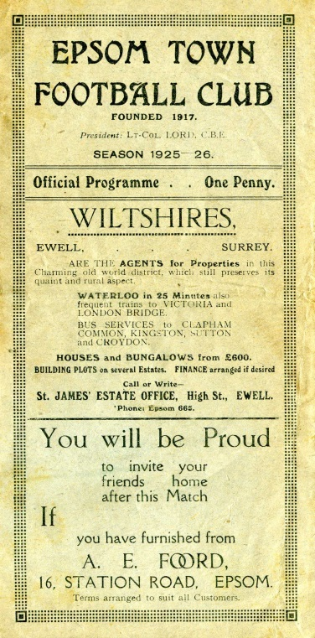
Tonight is our 206th Surrey Senior Cup tie. Over that period we have Won 99, Drawn 20 and Lost 85 with one match abandoned. Our goals in that time are F467 A400. It is also our 105th home tie with 91 being played away from home and ten being at neutral venues.

Our very first Surrey Senior Cup tie was played at Krooner Park, when we defeated Camberley & Yorktown as they were then known by three goals to one on 18th October 1924. We trailed at half time, but two goals from Reg Marlow and the other from Tom Kirk saw us through. A win at Egham gave us a home tie with Weybridge in the first round, but we surprisingly lost this 2-1 at home to end our first County Cup run.

In 1925/26 we started our run with a 3-2 win over Godalming and took revenge on Weybridge by a goal to nil in the next round. This earned us a big match at home to Athenian League Summerstown, who were having a wretched season at the foot of the table, yet they were still two levels above us, and defeated us 4-2 at West Street. (see programme right) The following year was a marathon, as we played six matches but still went out in the first round. We required two replays to dispose of Carshalton Athletic, but minus flu victim Reg Marlow (who was in the middle of his run of five hat tricks in five consecutive matches) we crashed 3-8 at home to Woking.

Summerstown again ended the run 5-1 in the first round in their final season at the Earlsfield Road ground after two wins over Leyland Motors and Aquarius, the Water Board side from Honor Oak, but the 1928/29 season would prove to be the most memorable to date. It didn’t start auspiciously as we were held 0-0 at West Street by the Westminster Bank. We won the replay before knocking out Isthmian League giants Casuals 3-1 at West Street, but the best was yet to come as we humbled Wimbledon 4-1 at Kingstonian’s old Richmond Road ground in the Semi-Final.

The Final ended disappointingly, in front of 4,600 at Guildford City’s Josephs Road ground, we led Redhill at half time with a Bronk Challis goal, but three goals early in the second half changed the match, and a late Bob Earl consolation was not enough as the Lobsters won their first County Cup.

The 1929/30 season was the first time that the Town lost their opening match, away to Tooting Town by four goals to two, but the next season we went all the way to the Quarter-Finals again, by virtue of replay wins over Camberley & Yorktown and Egham. We then earned a trip to Dulwich Hamlet’s old Champion Hill ground, and I mean the first one, not the enormous one that only people over the age of 35 can remember, but the one before that, which was actually to the side of the new ground, behind the big terrace.

In front of 5,000 we dominated the game, despite only winning 3-2 (see programme left) but we would never win at Dulwich again. Mitcham Wanderers ended that year’s run 2-1 at West Street.

For the 1931/32 season the Blues were finally awarded an exemption to the First Round, or last 16, along with the big guns in the County. A Reg Marlow hat trick saw us past qualifiers Wills Sports by 6-2 before Kingstonian made their first visit to West Street since they were present at the opening of the ground, and eased to a 4-1 win in a match that was all over as a contest by half time with the visitors being three goals to the good.

In the thirties we were a very good side. However you wouldn’t have known this from our County Cup performances as we lost in the opening round for four years in a row to, Tooting & Mitcham, Dulwich again, Nunhead and in 1935/36 3-4 at home to Met Police.

So in 1936/37 it was back to the qualifiers, although Banstead Hospital knocked us out in extra time in the final qualifying round. This was a pity as we would have faced our tenants Ewell & Stoneleigh in the next round, but Banstead knocked them out too and actually went all the way to the Semi-Final.
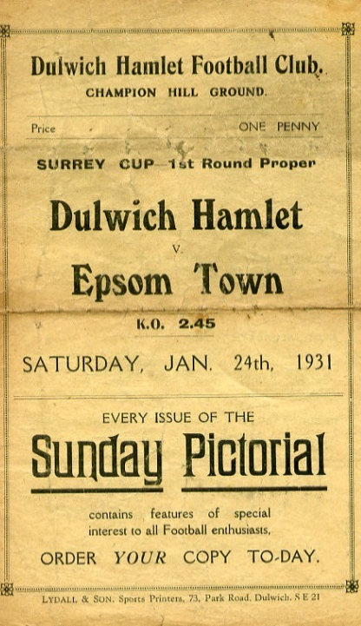
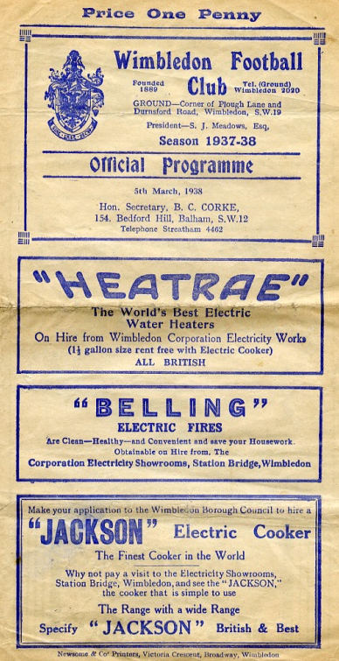
Despite going out in the qualifying rounds we received an exemption to the First Round again for 1937/38. We took full advantage, defeating Met Police 4-1 and Isthmian League Nunhead by five goals to one to reach the Semi-Final against the mighty Dulwich Hamlet. The match was played at the much-missed Plough Lane, Wimbledon see programme right), where goals from Rochester and Bruce ensured a replay at Richmond Road. There we were defeated 3-2 in extra time in a match where Jackie Pullen missed a sitter at the end of normal time with the score 1-1.

The press called it “a tragedy”, and despite Pullen netting in the extra period, we were unable to force another equaliser. It is worth noting that the Hamlet had won the previous year’s competition without conceding a goal, and were looking at repeating this achievement until they came up against us. (see programmes right and over page).

Tooting & Mitcham defeated us 3-2 at Sandy Lane in the opening round of the final pre-war competition During the war, the Cup was played for in 1939/40 by Epsom Town (losing in the Quarter Final to Nunhead), who continued through the war at West Street, before it was held in abeyance for a few years. It returned in 1943 with just nine teams entering, but Epsom Town reached the final, losing to

Tooting & Mitcham 3-1 at Sandy Lane in front of over 5,000 spectators (see programme below). However, the club would never win another match in the competition, losing over two legs to the Magpies again the next year, and to Vickers Armstrong after a replay in their final season of 1945/46.

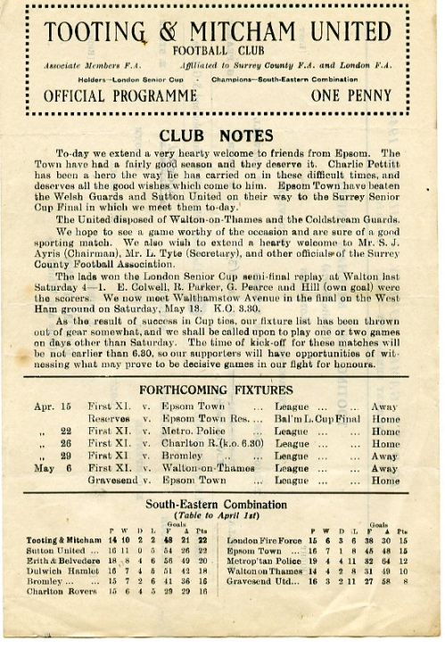
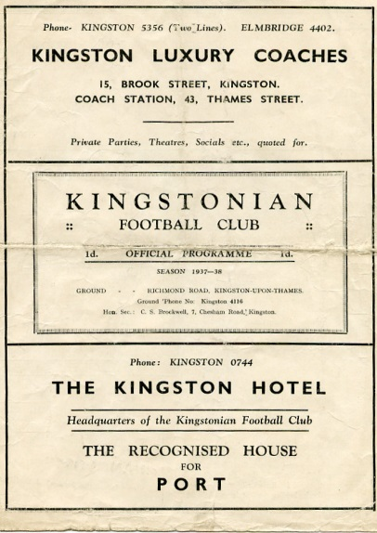
In that season Epsom F.C. defeated Carshalton Athletic 7-3 but were thrashed 6-0 in the Quarter-Final by the newly formed Corinthian Casuals at Richmond Road, where they ground shared with Kingstonian for a spell after the war. Despite reaching the last eight, we then had to play a qualifying round in 1946/47, but crashed out at home to Devas Institute. Oddly though we were back amongst the exempted clubs the following season, but it made no difference as we lost 3-2 at home to Corinthian Casuals again.

In 1948/49 we qualified past Devas (4-0) and Byfleet (6-1) but were defeated by the rising Walton & Hersham team 5-0 in front of 3,000 at Stompond Lane. The following season we were again exempt but Dulwich came away from West Street with a 6-0 win which put us back down amongst the qualifiers again!

It was a bit of a yo-yo really. We were obviously right on the edge of being one of the best eight clubs in the County, as we would rarely get beaten in the qualifiers.

McLaren Sports and Devas were beaten before we beat Hawkers, the Kingston based works side 6-1. Almost! We were nine minutes away from winning before were hit by a massive fog that was so heavy it caused our home Reserve team game to be called off at exactly the same time ten miles away in Epsom, with us leading 4-0 at the time. It was an unfortunate day! We played the following week and edged through 4-3 before again being hammered by Corinthian Casuals, this time 7-1 at West Street.

We were facing a regular scenario. Beat a few average teams before coming up against either Casuals or the Hamlet. For the next three years it would be the latter, winning 4-2 and 4-3 at West Street in consecutive seasons. However, the 1953/54 season would see the tables turned for a change.

Firstly, we received another exemption, for reaching the Quarter-Final the year before, and the draw was kind. We defeated Addlestone and Malden Town without conceding, and faced our nemesis in the Semi-Final at Plough Lane, where a Roy Dymott goal was enough to secure a draw

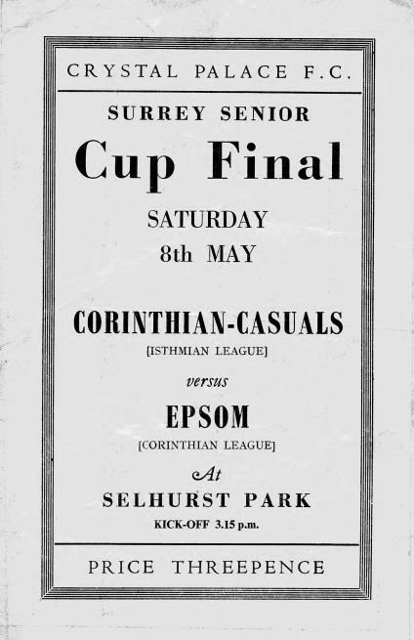
there, just as we had 16 seasons before. This time the replay was at Sandy Lane, where 7,000 witnessed a stunning comeback. We trailed 2-0 with eighteen minutes left, but Gordon Hurst pulled a goal back, and then right on full time as the crowds were beginning to drift away Bill Wiles equalised, with Bobby Avis securing the win with a goal in the second period of extra time. (see programmes above) However, our reward for defeating Dulwich was a Final against Corinthian Casuals! The game was played at Selhurst Park in front of 6,159 and was a let down with our boys conceding once in each half, despite being the better side on the day. (see programme left)

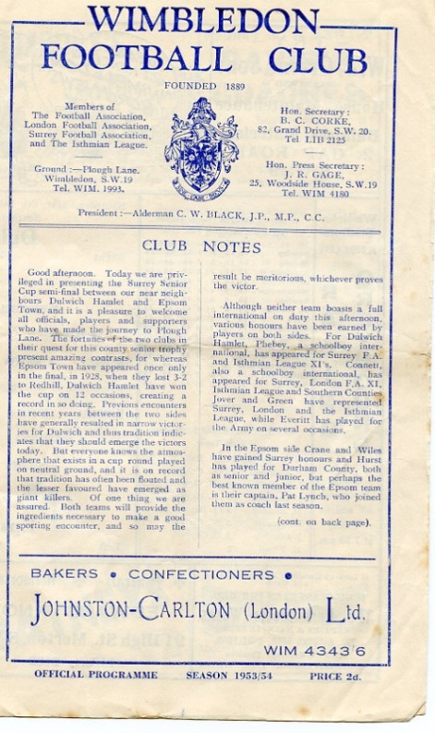
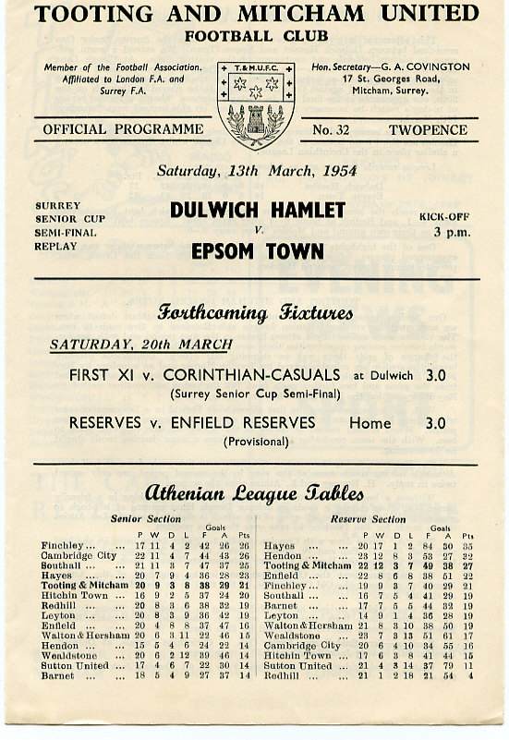
It was Dulwich again in 1954/55 that knocked us out 4-1 and although we edged past Banstead 3-2 on our first visit to Merland Rise, Tooting & Mitcham put us out in 1955/56. The next season was one of our best though, as we battered Kingstonian 5-1 at West Street before then smashing Dulwich Hamlet up 5-3. However, the semi-final brought an unlucky 2-1 defeat to Wimbledon at Sandy Lane.

It seems downright bizarre that we always seemed to

play the same teams, yet never met Sutton United in this competition until 1957, when Johnny Bangs and Jan Sorensen were the scorers in a 2-0 win at West Street. (see programme right). It would be twenty-four years before we would meet again.

In the meantime our luck was about to change for the worse. Woking defeated us 4-2, and then we crashed 5-1 at Dorking in December 1958. This result sent us back to the qualifiers, where we would remain until 1981. As our fortunes plummeted, we only reached the First Round once in the sixties, when wins over Whyteleafe, Chobham (after a replay, awarded because the pitch there was undersized) and Camberley gave us a home tie against, yes, Dulwich again! The attendance of 608 was the best we’d get until the Vase run of 1975 as the visitors won 2-1.

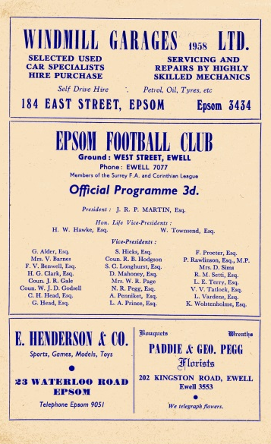
And it was 1975 when we next reached that stage of the competition, slipping up 3-4 at Addlestone, although at 4-0 down we gave them a fright and this helped when we met and defeated them later that season in the F.A.Vase Quarter-Final.

In 1976/77 we reached the First round again, losing 2-1 at home to Walton & Hersham after a replay. This earned us an exemption to the final qualifying round, ahead of many lower league sides, but not quite up with the big boys yet. Tooting & Mitcham and Egham defeated us in the first round in the next two seasons, with Dorking knocking us out in the qualifiers the next year.

In 1980/81 we had a good side, but no one would have expected what happened next. We opened up with a narrow 2-1 win over Westfield before winning 6-0 at Ash United in the First Round. The Quarter-Final drew us at Walton & Hersham and we got a 1-1 draw there, finishing them off in the replay 4-2. Enter Sutton United, who were having a very good season themselves which would end at Wembley for an F.A.Trophy Final. We held our more illustrious opponents goalless before winning the replay at West Street 3-2. After beating Sutton, Woking held no fears for us, as they were bottom of the Isthmian Premier Division, and we defeated them 2-1 at Sandy Lane to win the cup for the first, and so far only time in our history. (see programme left)

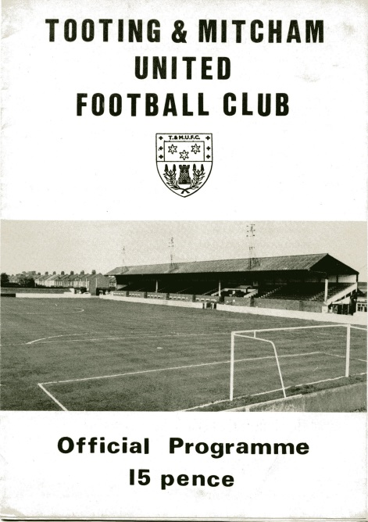
As holders, this had the added benefit of giving us a full exemption again, but despite defeating Tooting & Mitcham and Walton & Hersham, we were robbed on a technicality against Croydon.

Pat O’Connell had left the club, taking much of the team with him and Adrian Hill had limited time to get players in. In addition the Surrey F.A. rules stated that a player had to be registered for 28 days before playing in this tie, so we had all sorts of troubles even fielding a side. Leading striker Steve Hill even played in goal for us, despite having a stress fracture in his shin that prevented him taking an outfield role, and Croydon won 4-0, ending our brief hold on the trophy in criminally farcical circumstances.

In January 1983 Sutton defeated us in the County Cup for the first time ever with a 2-1 win at Gander Green Lane, and the following season the two teams met in the Final, after we had defeated Addlestone & Weybridge (after a replay), Banstead and Croydon, again after a replay. However, we were blown away, losing 4-0.

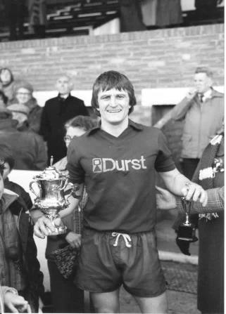
And they did it again the following season with a 4-1 win at West Street after we had held them goalless just two days previously at Sutton. There was a temporary respite in 1985/86 when it was Kingstonian that knocked us out 2-0 at Richmond Road, but it was Sutton again in the Semi-Final of 1986/87 by five clear goals.

We reached the Semi-Final again in 1988/89 but despite holding Carshalton Athletic 2-2 at home, we were harshly defeated 3-0 at Colston Avenue, and three narrow quarter-final defeats in three years followed to Woking, Whyteleafe and Carshalton again.

Since then we have achieved very little in the competition with exception of a Quarter-Final appearance in 2001/02 when we were defeated 3-1 by a Wayne Routledge inspired Crystal Palace, and in 2008/09 when we reached the Semi-Final, aided by an historic and fantastic 3-2 win at Sutton United, plus wins over Redhill and Corinthian Casuals. This gave us the opportunity to visit Step Three side at the time Ashford Town (Middx), but they were too strong for a tired Epsom team and eased through 4-1, despite Robbie Burns equalising to make it interesting for a while.

The competition’s recent reorganisation means that there are no exemptions any more, which makes for a more open draw, and maybe as a result of these potential extra matches, some of the bigger sides have played weaker teams in recent years. This of course does open the way for smaller teams to progress in the competition and recently we have seen Merstham, Ashford Town (Middx) and Godalming Town winning the trophy. Who knows, maybe these days it isn’t as impossible to repeat our 1981 win as you might think!

Left: Our Captain Peter Gaydon lifts the Surrey Senior Cup at Sandy Lane on Easter Monday 1981.

Match and Ball Sponsorships – 2016/17
Opponent | Date | Match Sponsor | Ball Sponsor
Gravesham Borough | 07/08/16 | Club President - Stella Lamont
Gravesham Borough | 07/08/16 | Relocation Committee Member - Mike Lovett
CB Hounslow United | 16/08/16 | EEFC Management Committee
Abbey Rangers | 23/08/16 | Steve & Geoff Dyke
Horley Town (11.30am) | 29/08/16 | In Memory of Chris Henry
Abbey Rangers (LC) | 06/09/16 | Paul Merritt
Camberley Town | 10/09/16 | Building Shop Ltd
Knaphill | 24/09/16 | EEFC Holding Company Director – Pete Lumm
Bridon Ropes (FAV) | 22/10/16 | George and Joseph Saunders
Sutton Common Rovers | 08/11/15 | Alex McKay Senior
Abbey Rangers (FAV) | 13/11/16 | EEFC Holding Company Director – Dave Ellins
Windsor | 15/11/16 | In Memory of Wally Dyke
Bedfont Sports | 19/11/16 | John Bonner
AFC Hayes | 26/11/16 | Jack Jarman
Chipstead (SSC / DWT) | 06/12/16 | Trevor Stotten
Hanworth Villa | 13/12/16 | Roger and Carol Farrell
Chertsey Town | 17/12/16
Raynes Park Vale (11.30am) | 27/12/16 | In memory of Dave and Liz Marshall
Spelthorne Sports | 07/01/17 | Building Shop Ltd
Guildford City (SSC) | 10/01/17 | Super Six Winner – Rita Christian
Guildford City | 17/01/17
Bedfont & Feltham | 21/01/17 | Programme Editor - Richard Lambert
Badshot Lea | 04/02/17
Westfield | 18/02/17
Walton & Hersham | 04/03/17
Hartley Wintney | 18/03/17
Farnham Town | 25/03/17
Colliers Wood United (1pm) | 14/04/17 | Good Friday match – make a note!
North Greenford United | 22/04/17 | Club President - Stella Lamont
For League, League Cup and Surrey Senior Cup Matches:
Match sponsorship - £40.00 Match ball sponsorship - £25.00. Combined £55.00.
For F.A. Cup and F.A. Vase matches:
Match sponsorship - £50.00 Match ball sponsorship - £30.00. Combined £65.00.

Sponsorship includes: (x2 for match, x3 for match and ball)

Admission, programmes, hospitality and advertising and mascot for the day (if required).
If you are interested, just speak to a Committee Member, or drop me an email at: richard.c.lambert@gmail.com


We also thank our Kit Sponsors INTERCEM

Salts Super Six Predictor
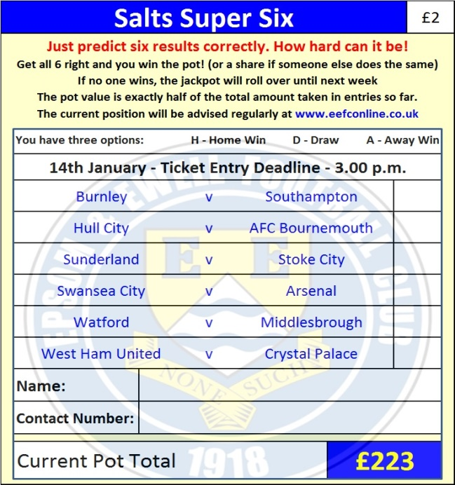
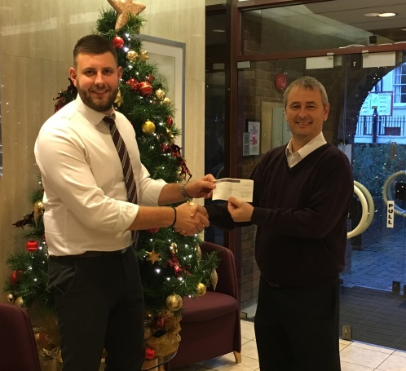
The Salts Super Six Predictor is live again for today’s match and the tickets are on sale at today’s game to the left of the gate. The matches are to be played this Saturday.

The jackpot was won recently but is already increasing and is now up to £223.

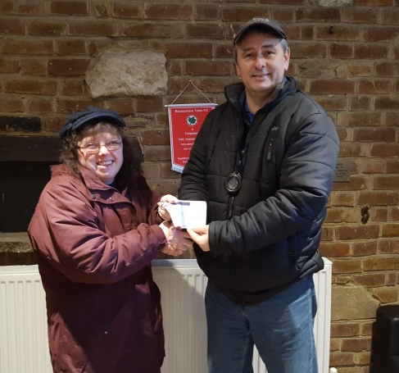
The competition is easy to play! To win, you simply need to predict the results of six matches correctly from the three options, fill in the form and make sure it is back with our seller before the deadline on the ticket. The latest fixtures are shown below.

If you are a club regular, you just need to place your name on the sheet, although if you aren’t, then we’ll need a contact number from you too. We will announce any winners on the website within three working days, so don’t worry, we won’t miss you!

Please note that if there is more than one winner, the prize pot would be shared between the winners. All you need to do now is have a go, as many times as you like!

Our two winners Matt Parker and Rita Christian are pictured above. Good luck!

Surrey Senior Cup – Third Round
Tuesday, 10th January 2017 - Kick-off 7.45 p.m.

Epsom and Ewell  (Royal Blue & White hoops) | V |  | Guildford City  (Red and White)
Squad | NUMBERS |  | Squad
Michael Eacott |  |  | Luke Badiali
Adam Heagney |  |  | Matt Petts
Matt Tanton |  |  | Alex Rose
James Taylor |  |  | Darryl Siaw
Craig Hastings |  |  | Callum Wilson
© Dan Dean |  |  | Dan Akinwande
Jordan Gallagher |  |  | Adriano Moraes
Matt Farrell |  |  | Kiye Martin
Rob Hendry |  |  | Shawn Lyle
Savvas ‘Agi’ Panayiotou |  |  | Leon Lalor-Dell
Matt Ferdinando |  |  | Cameron Karembo
Jason Nwachukwu |  |  | Jamel Johnson
Reisse Griffin |  |  | Greg Haydon
Daryl Cooper-Smith |  |  | Lee Hall
Alex McKay |  |  | Mario Embalo
Daniel Rose |  |  | Suleiman Djalo
Alistair Turpie |  |  | Alpha Cauwenbergh
Charlie Clark-Gleave |  |  | Tom Booth
Matt Smith |  |  | Tom Bingham
Glyn Mandeville | MANAGER |  | Steve Dormer
Matt Smith | ASSISTANT |  | Chris Balchin
Steve Eacott / Alex McKay /  Jimmy Hendry | COACHES / PHYSIO
REFEREE: Z.Jacquart
ASSISTANTS: T.Hatt, R.Wells
Today’s Match and Match Ball are kindly sponsored
By our recent Salts super Six winner Rita Christian

OUR NEXT VISITORS TO HIGH ROAD (again!)
Guildford City
Combined Counties League – Premier Division
Tuesday 17th January 2017 – 7.45 p.m.

